Supported By: The Ocean Conservancy; The Puget Sound Partnership

Disease outbreaks are a challenge because they are like lightning strikes—occurring unpredictably and rapidly. The challenge intensifies when the outbreak occurs in the ocean.
- Costly epidemics can impact fishing and marine industry. During the early 1990s, there were large scale mortalities in shrimp culture ponds in most major producing countries due to white spot syndrome virus (WSSV) with an estimated loss of around $6 billion;

- Disruptions to biodiversity can threaten tourism revenue; large-scale coral bleaching and disease can close marine parks and destroy coral reefs;

- Massive seagrass epidemics, occurring first in the 1930s and more recently in the 1980s, in Florida decimated local populations that had provided valuable ecosystem services and habitat for important species.

- Currently, sea stars are dying by the millions, appearing “deflated” and then “melting” into a white, gooey substance. Sea star wasting syndrome is one of the largest mortality event marine diseases scientists have ever seen, affecting over 20 species on the west coast. This bill declares the sea star wasting syndrome as a marine disease emergency.
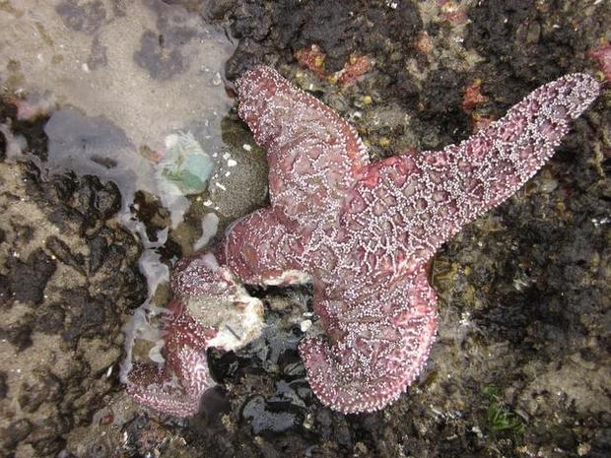
Timely response requires significant scientific resources and federal coordination; unfortunately, the current multiagency response network is fragmented and inadequately situated to rapidly respond to developing challenges in the marine environment.

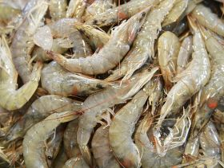
The Marine Disease Emergency Act would establish a framework for declaring and responding to a marine disease emergency; providing rapid coordination and ensuring scientists have access to resources in order to proactively address issues affecting our valuable marine fisheries and biodiversity.

Bill Summary

Declares the sea star wasting syndrome as a marine disease emergency.

Establishes parameters for marine disease emergency declaration and 120 days rapid response plan.

- Establishes a declaration process for the Secretary of Commerce, acting through the Administrator of NOAA, to declare a marine disease emergency;
- Outlines response plan parameters, including individuals and entities at federal, regional, state and local levels that can assist the Secretary in implementing a coordinated and effective response aimed at minimizing the impacts and preventing further transmission.
- Requires a post-emergency report detailing current disease status and providing recommendations for improving responses to future marine disease emergencies.

Establishes a permanent, volunteer working group to advise the Secretary when declaring and responding to a marine disease emergency.
- Composed of seven (7) appointed members, serving three year terms;
  - Four (4) from federal agencies;
  - Three (3) specialized members of the public
- The working group requires individuals have specialized knowledge in epidemiology, ecology, microbiology and expertise in responding to disease outbreaks or ecological disasters.
Establishes a national data repository.
- To facilitate the development, coordination, and rapid dissemination of research;
- Links different datasets across the country to assist researchers in identifying and developing strategies for addressing marine diseases.

Establishes a “Marine Disease Emergency Fund” under Treasury in order to accept donations from the public and the industry. (Similar to what is in place for Marine Sanctuaries.)

Authorizes $15 million a year from 2015 – 2019 for emergency framework.

TIMELINE
Prior to Declaring

- *within 24 hours* After receiving notice that a marine disease may be occurring, the Secretary of NOAA shall contact members of the working group within 24 hours for guidance on whether or not the event qualifies as a marine disease emergency;

- *within 7 days* Secretary must decide whether or not a marine disease is occurring.

Once Declared

- *within 21 days* Develop a written plan for responding to a marine disease emergency and publish the response plan on a publically accessible website. Plan must contain:
  - List of Federal/regional/state/local agencies who can assist in implementing a coordinated and effective response;
  - Description of the steps necessary to diagnose the cause of the marine disease emergency;
  - Training, mobilization, and utilization procedures for personnel, facilities, and other resources necessary to conduct a rapid and effective response;
  - Assessment of the potential effects of the marine disease;
  - Strategies to minimize transmission and deaths of marine species;

- *After 120 days* a marine disease emergency shall terminate when the Secretary declares that the emergency no longer exists or 120 days after the declaration is made, whichever comes first. **the Secretary may extend for another 120 period if the Secretary deems it necessary**

Post-Emergency
- *No later than 90 days after the termination of a marine disease emergency* a post-emergency report is required to be published on a publically accessible website, describing: the response to the marine disease emergency and providing recommendations, if any, for improving responses to future marine disease emergencies;

